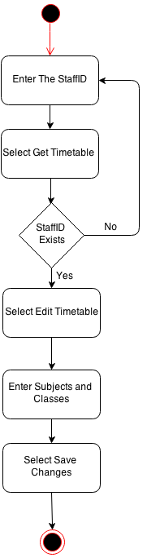Create Timetable

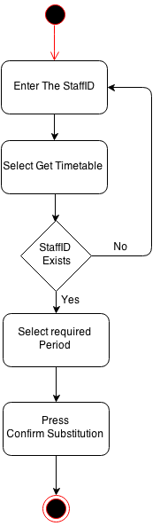Substitute Teacher

Print Timetable

